CS5551 FIRST INCREMENT REPORT
Group:17 Project Title: Police database system
1.Ravi Teja Soma
2.Shashank Reddy yata
3.Vikas Koduri
4.Anand sanjay reddy Gundapureddy

I. Introduction:
The Police have been handling crime-related issues for people. The Police is using some paper works and they have go through control room staff to track these details. This will take some time and even they miss some important criminals they have to catch immediately. To tackle the problems from our application police can search for criminals and their records in their hands. This application will useful to police for crime prevention, detection, conviction of criminals depending on a backbone of Information Management. This app allows police to manage criminal records, access control, report generation and task assignment.

II.Project Goal and Objectives (revised):
- Overall goal:
Main goal of this application is to search for a criminal and gets their details based on search so that it is easy for police to catch the criminals.
- Specific objectives:
Police search for a criminal and based on search he will get the results.
From the results he can select the criminal.
He can observe his movements and tack him.
He can send details to other officers to track him.
- Specific Features:
Based on the rank in the department each one gets the results and criminal details.
- Significance:
From this application police will sign in and search for criminals so that he can easily access criminal details on his hands in seconds without going through big process to get their details.

III.Project Plan:

Zenhub screenshots:
For the first increment we have created the login page and signup page. We added UML diagrams for our projects and wire frames.
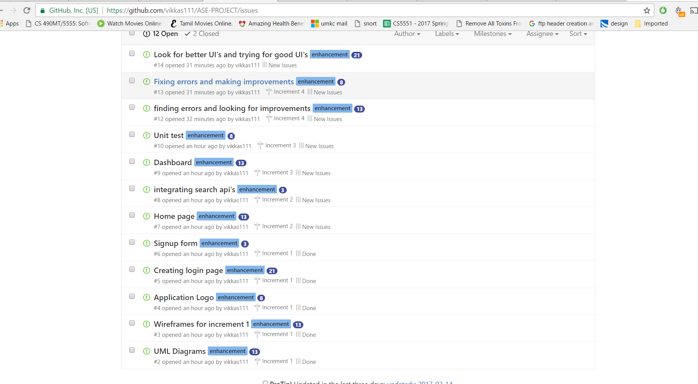

2.Project timelines, Members, Task responsibility:

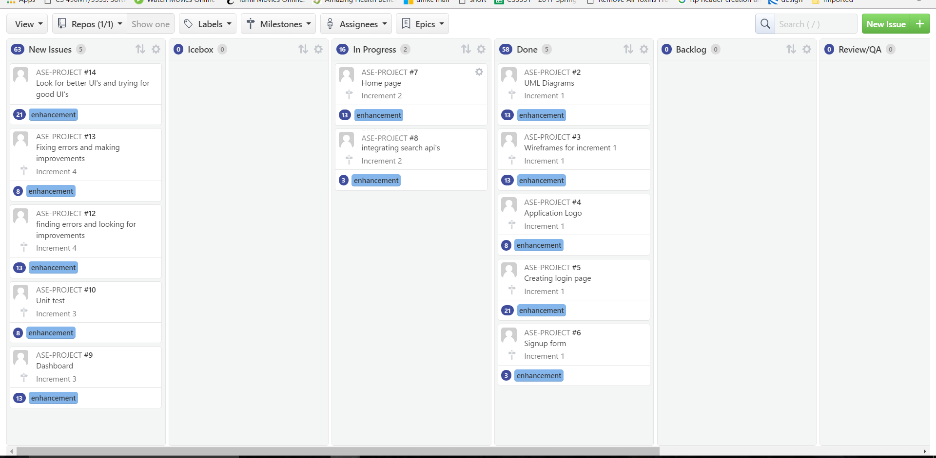

3.Burndown Chart:

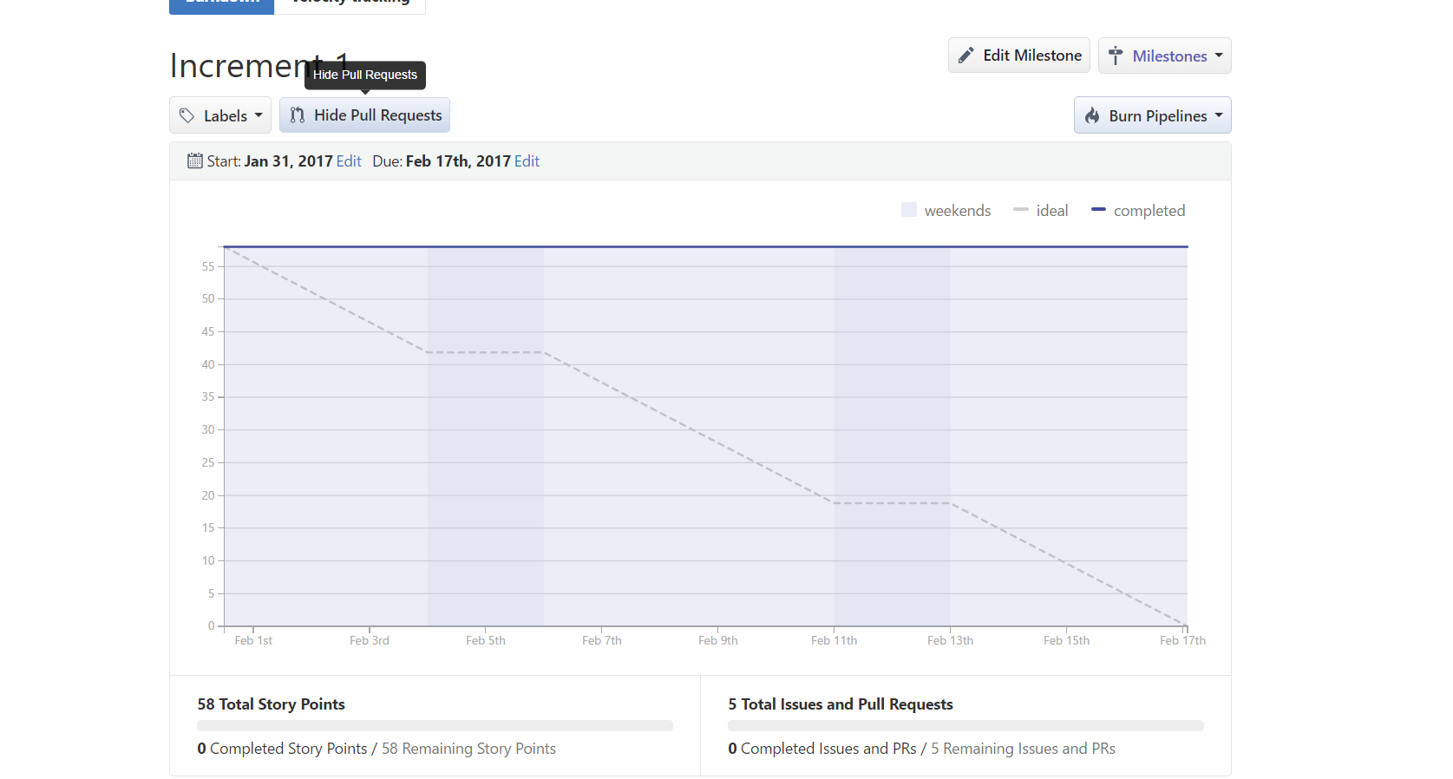
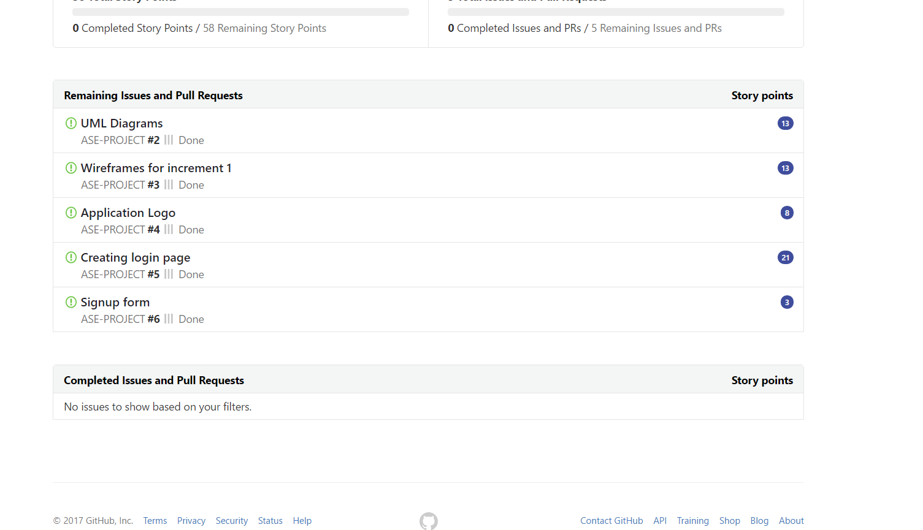

IV.First Increment Report:

Existing Services/REST API
API’s to be used
- Google Maps API
- Criminal database API
- E-mail Widget.

Detail Design of Features (using tools):

Wireframes and mockups:
Login page:
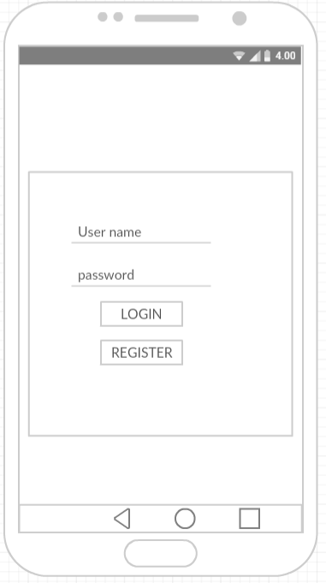

Registration page:

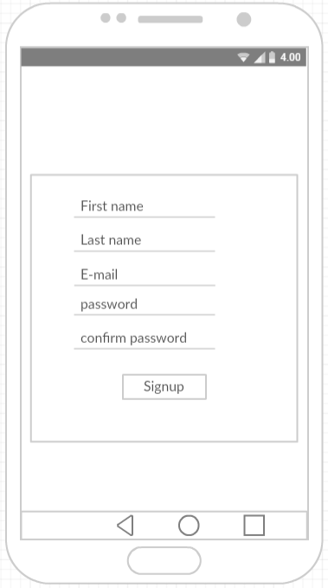

Class Diagram:

Use Case Diagram:

Sequence Diagram:

Collaboration Diagram:

Activity Diagram:

Implementation:

Login page:

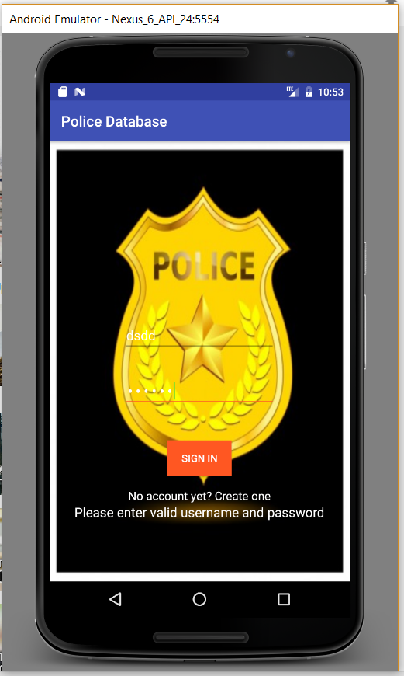

Signup page:

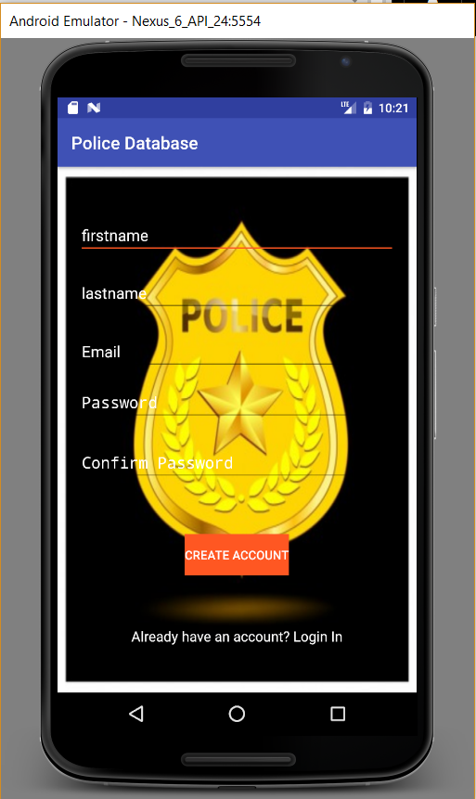

Deployment:
Our app in virtual Android device
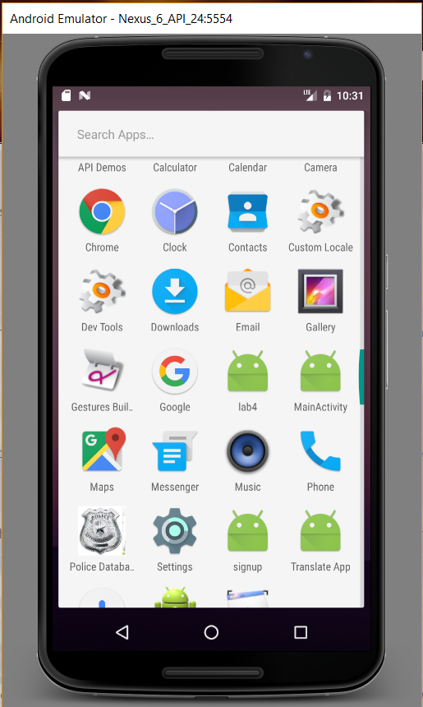

Testing:

CASE | TEST CASE DESCRIPTAION | EXPECTED RESULT | ACTUAL RESULT
Login | Enter invalid username and password | Error message should pop up saying invalid credentials. | PASS
LOGIN | Enter invalid username and valid password | Error message should pop up saying invalid credentials. | PASS
Login | Enter valid username and invalid password | Error message should pop up saying invalid credentials. | PASS
Signup | Email id format should end with @mail.com | Give error message incorrect email id format | PASS
Signup | Password of length 8 characters | Gives error message password is weak | pASS

While signup entered a wrong email then it says wrong email address

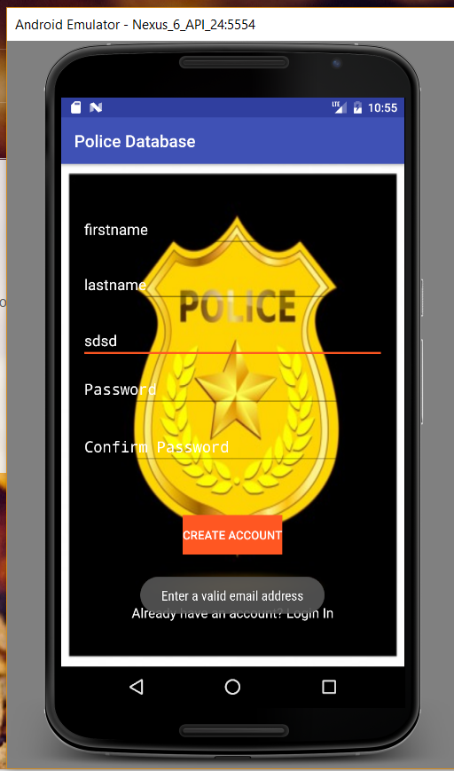

While password requirements are not satisfied
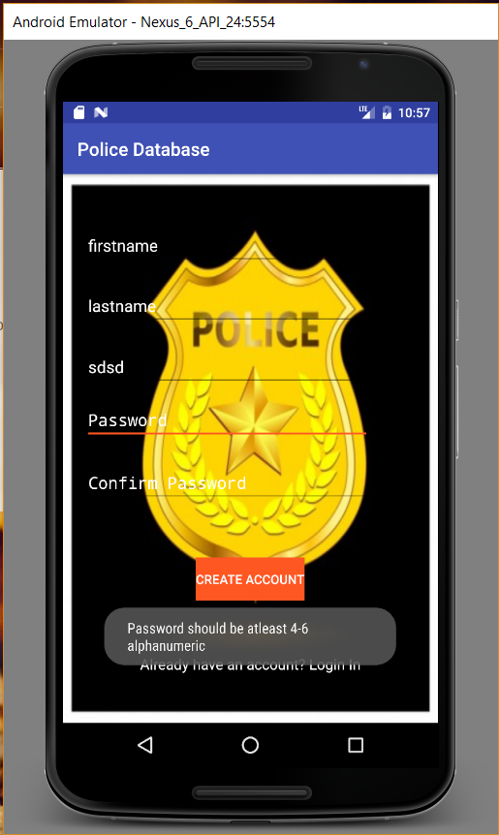

Invalid login details

6.Project Management
Implementation status report
Technologies Used: Android SDK, HTML, CSS, JS, Angular JS, J2EE.
Work Completed :
- Design and Architecture of the Application
- Login and Registration using Bootstrap.
- Login and Registration using Android.
- Collecting and Integrating the API with the application.
- Improving the User Interface of the application.
Contributors:
- Ravi Teja Soma – 25 %
- Vikas Koduri – 25%
- Sanjay Reddy Gundreddy– 25%
- Shashank Reddy yata – 25%

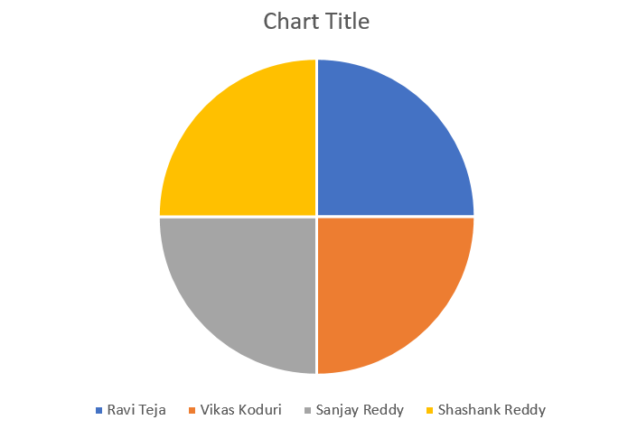
Bibliography:
W3schools
Stackoverflow.com

Wiki link: https://github.com/vikkas111/ASE-PROJECT/wiki
GitHub link: https://github.com/vikkas111/ASE-PROJECT/tree/master/Increment%201

